**Lab6 - Testing Document**

**Testno#1**: Create Database ‘student_db’

Create database student_db;

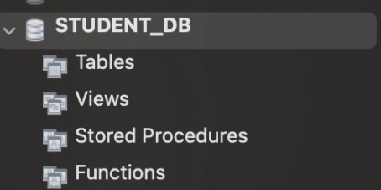

**Result : successful**

**Testno#2**: Run the application

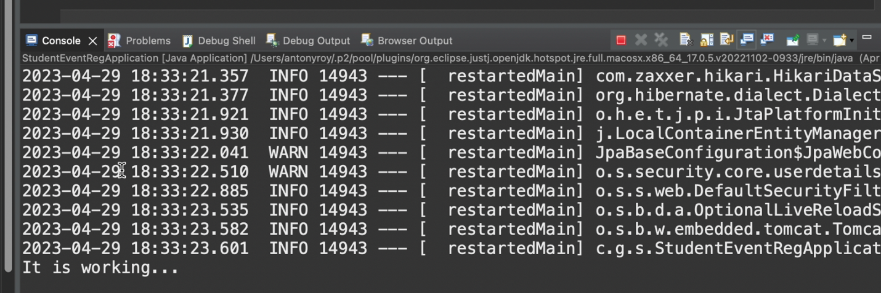

**Result: succesful**

**Testno# 3** : Checking the password of amit and kumar

Login as a kumar (role: admin )

Add the following

|  |  |  |
| --- | --- | --- |
| username | Password | Role |
| Kumar | 123 | ADMIN |
| Amit | 123 | USER |

Test 3(a) Enter wrong password, it should show the error message

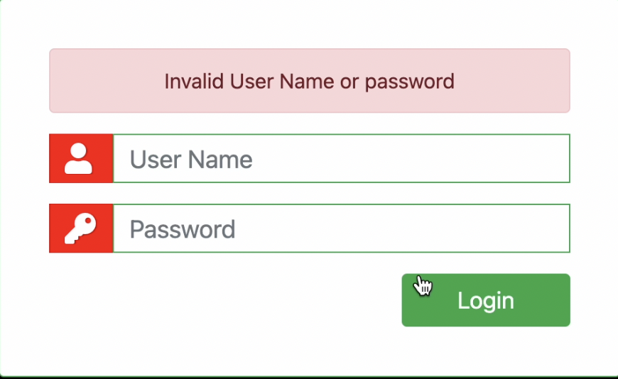

**Result : successful**

Test 3(b) Enter correct password, it should successfully login and application can be run on the browser

**Result:SUCCESSFUL**

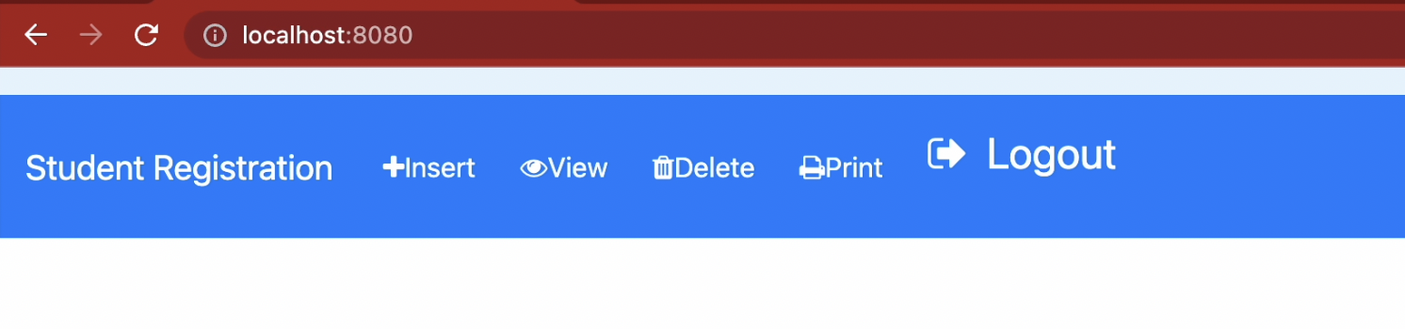

TestNo#4(a) : Checking the ‘admin’ role

|  |  |  |
| --- | --- | --- |
| username | Password | Role |
| Kumar | 123 | ADMIN |
| Amit | 123 | USER |

Login as ‘kumar’ and click on all the Menus and it should be successful for all menu item.

Click on Insert

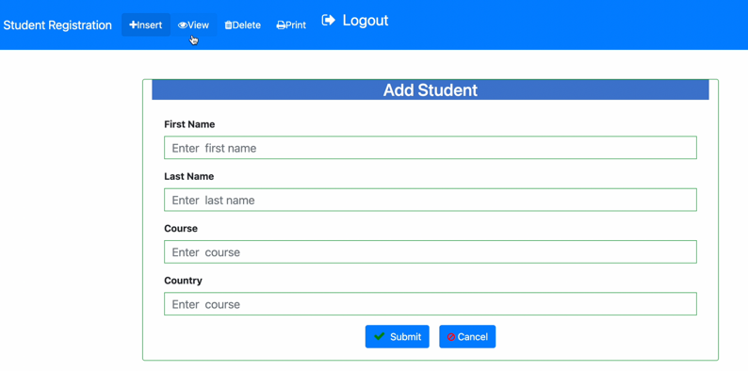

Click on View

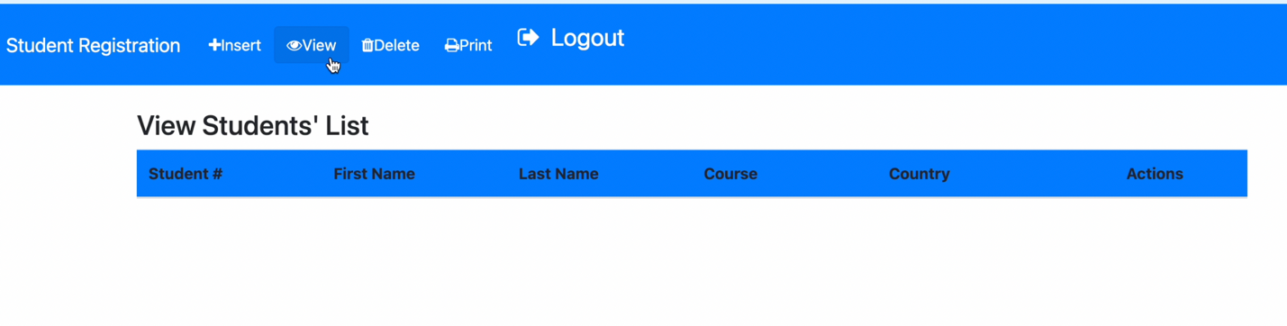

Click on Delete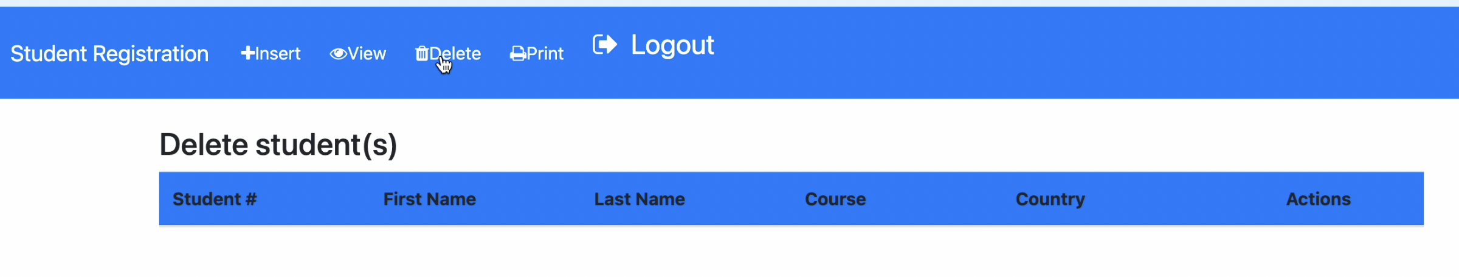

Click on Print

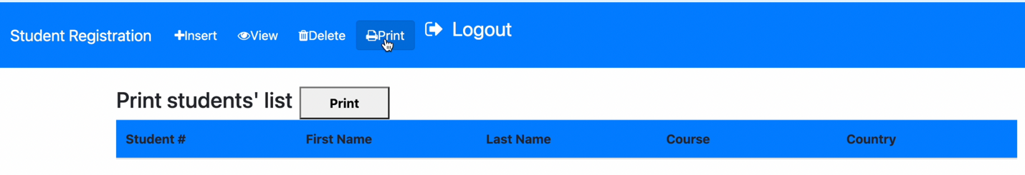

**Result: successful**

All the screens opened for kumar (role= admin)

**TestNo#4(b)** : Checking the ‘USER’ role

Login as ‘amit’ and it should not allow the user to click on any menu item except view. For all other pages(Insert,Delete,Print) it should show access denied

**Result: successful**

It showed as below

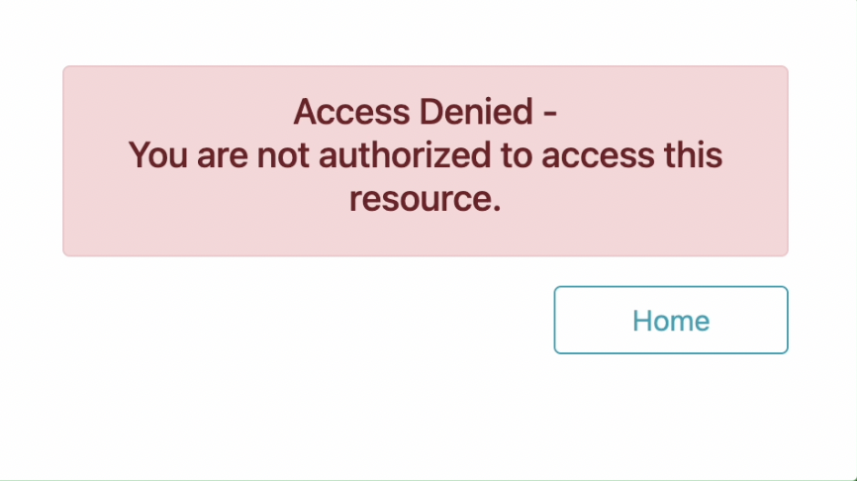

**Testno#5**: Login as kumar(admin) Insert four students

|  |  |  |  |  |
| --- | --- | --- | --- | --- |
| **Student Id** | **FirstName** | **LastName** | **Course** | **Country** |
| 1 | Suresh | Reddy | B.Tech | India |
| 2 | Murali | Mohan | B.Arch | Canada |
| 3 | Daniel | Denson | B.Tech | New Zealand |
| 4 | Tanya | Gupta | B.Com | USA |

**Result: Successful**

**TestNo#5(a)** : Click on view and it should show all the records

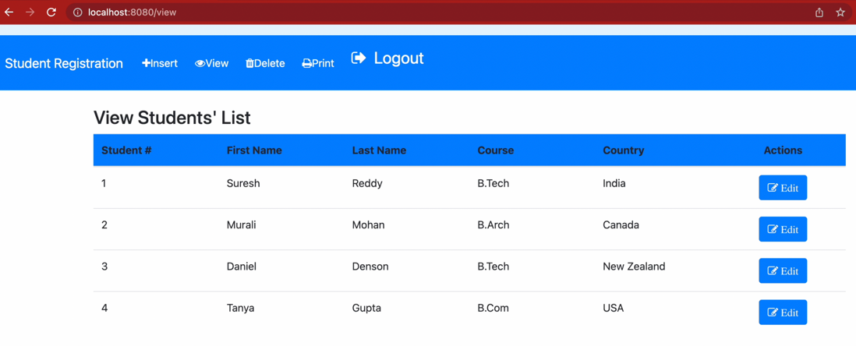

**Result:Successful**

**TestNo#5(b)** Check the database

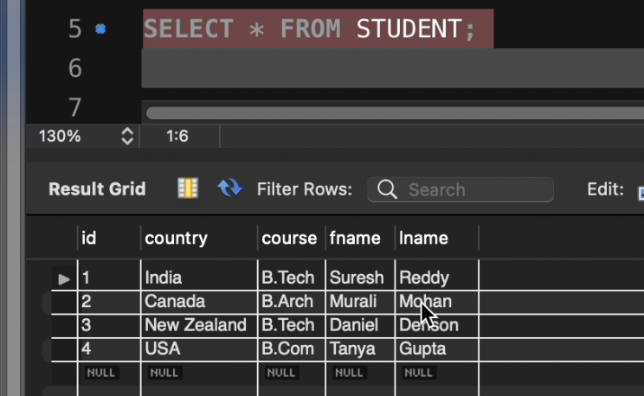

**Result:Successful**

**TestNo#6 :** Click on view and edit one of the record with changes and then save it

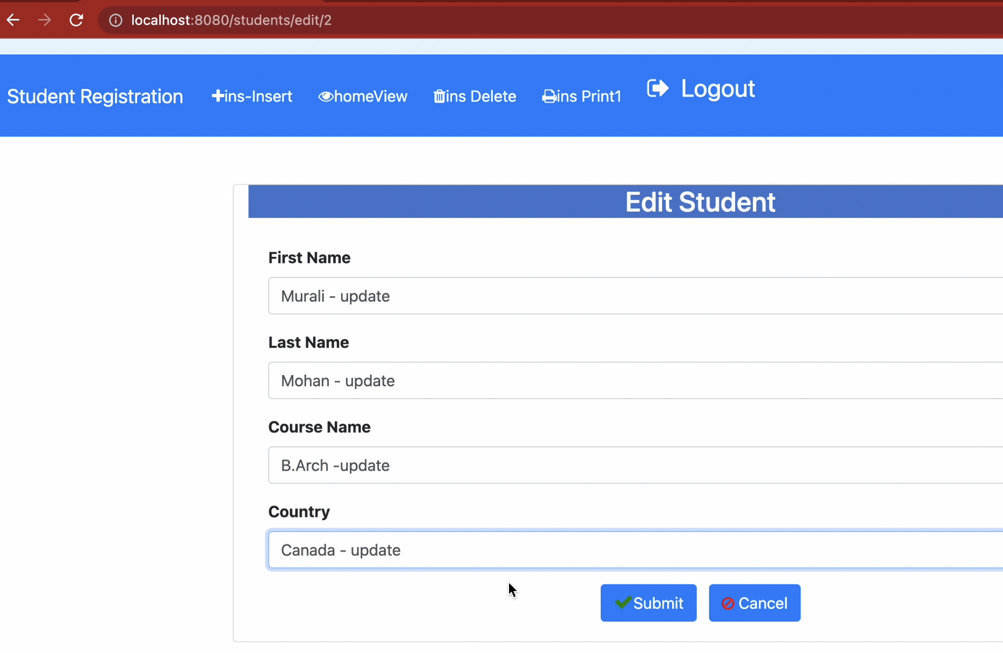

Then click on the view, it showed the updated values

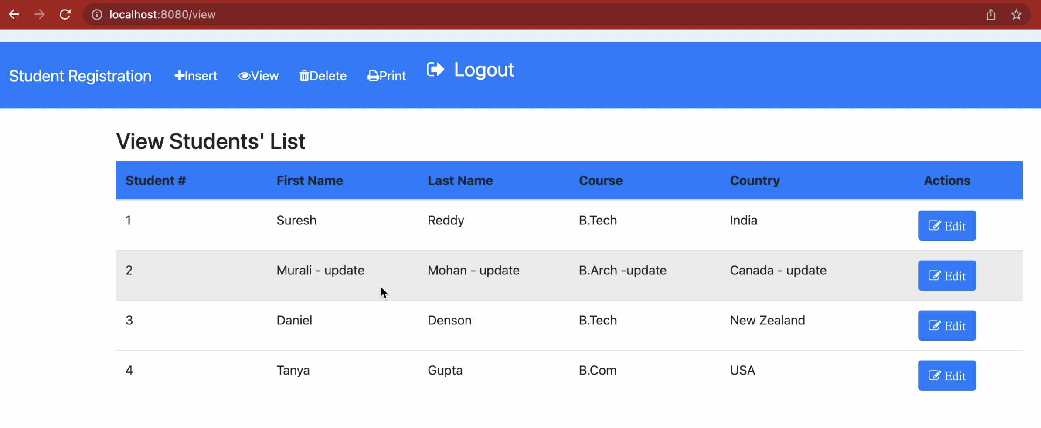

**Result:successful**

**TestNo#6:** Delete the record no.2(Murali) and check the database

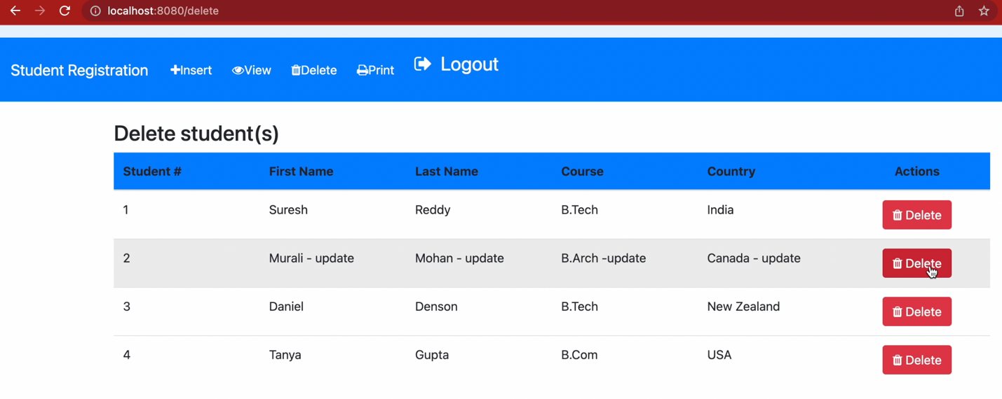

Record is deleted from the list(below)

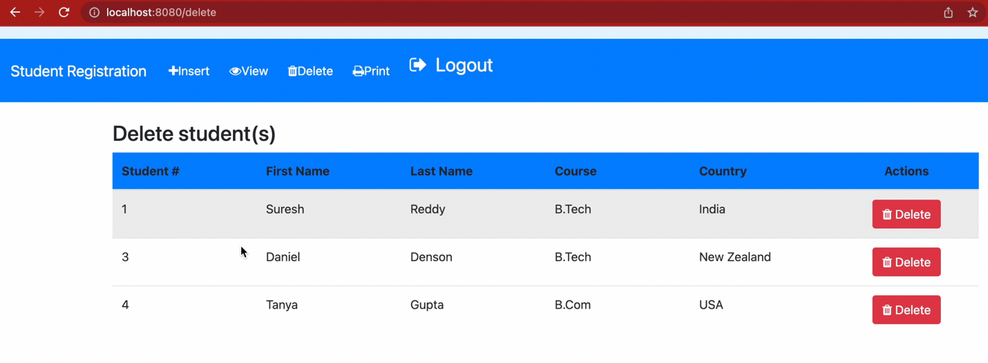

Database:Missing record no.2 from the student table

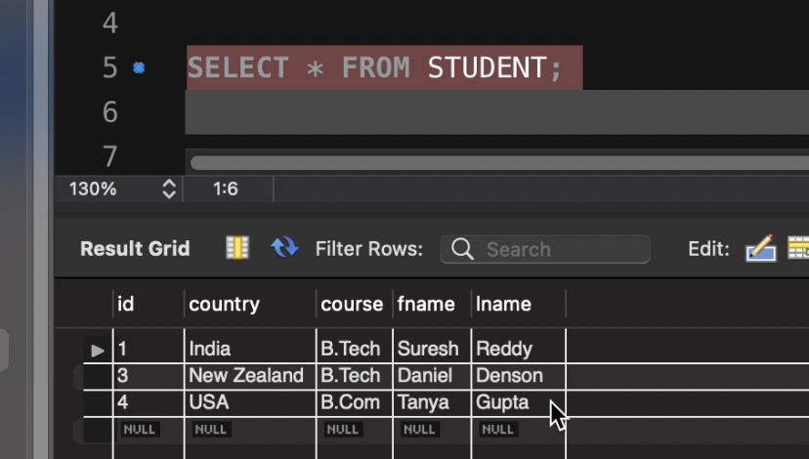

**Result: Succesful**

**TestNo#7:**Click on ‘Print’ menu item and click on the print button. It should open up the print details

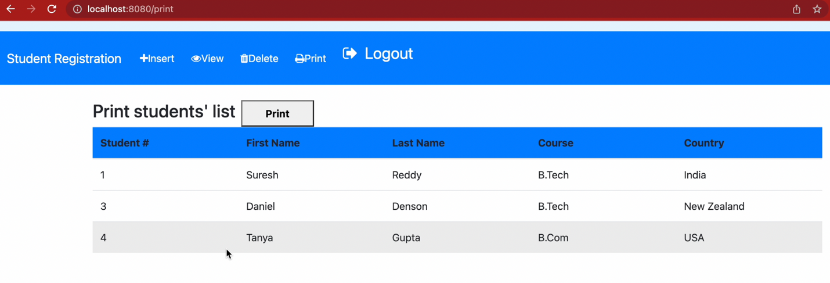

Clicking on print button, it opened the printer options for printing.

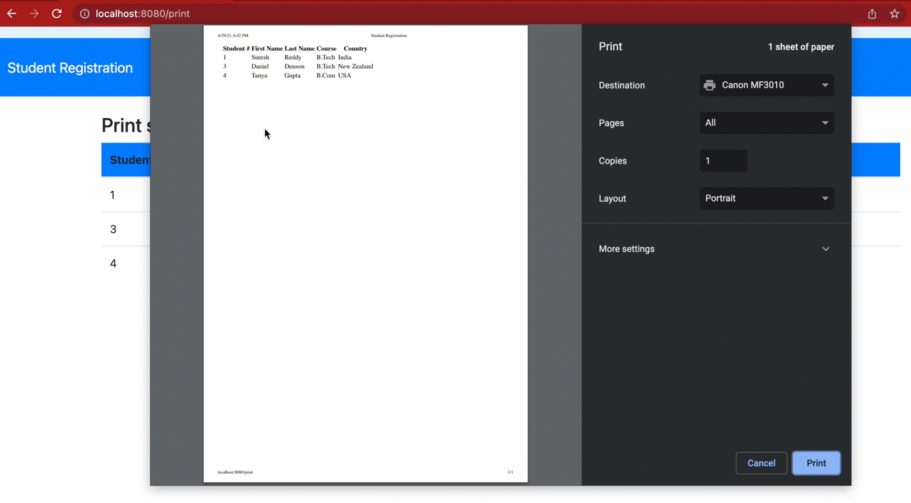

**Result:Successful**

**TestNo#8**:Login as amit and go to all the menu items.

Only View and save is allowed for the user. Rest of the menu items are not allowed

Clicking on Insert

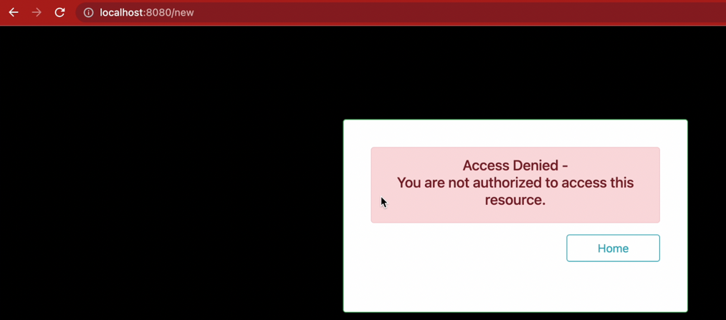

Clicking on Delete

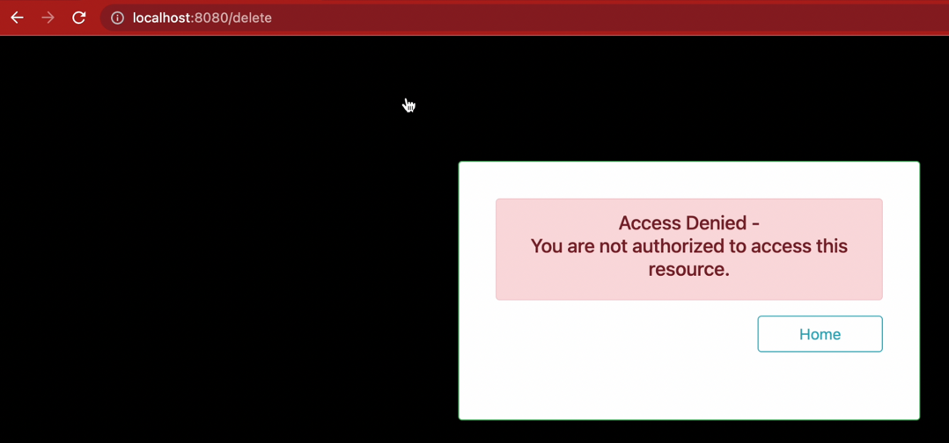

Clicking on print

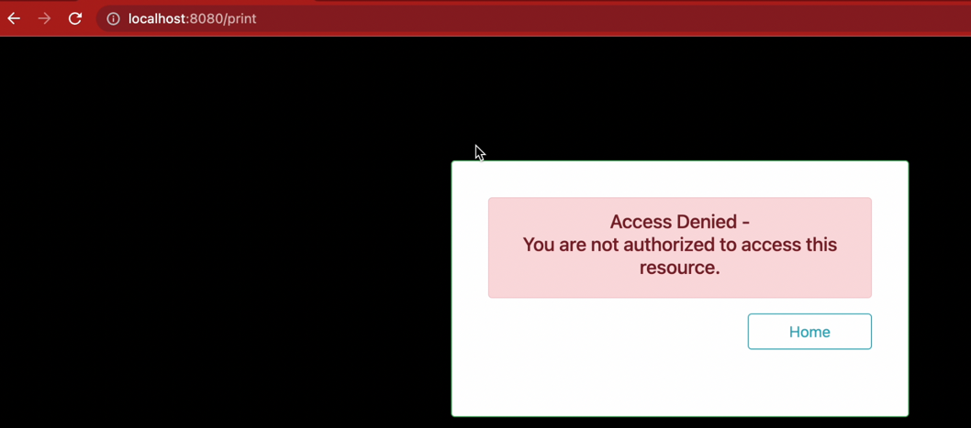

**Clicking on View**

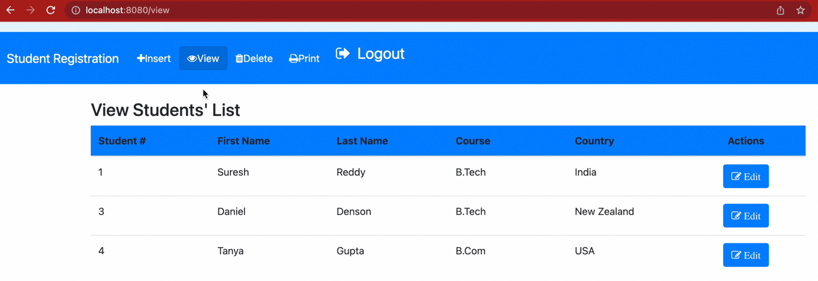Made changes on the record using username ‘amit **‘ (Role=user)**

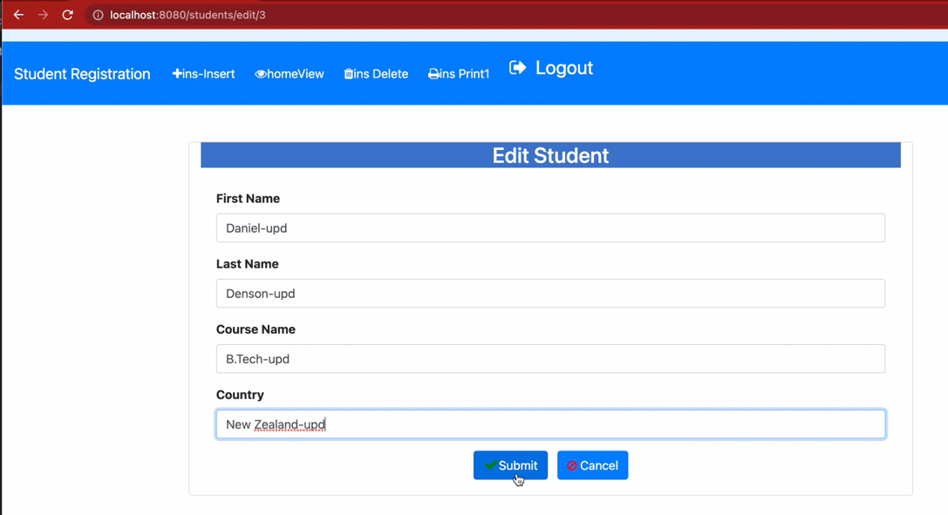

It updated the record using the username ‘amit’

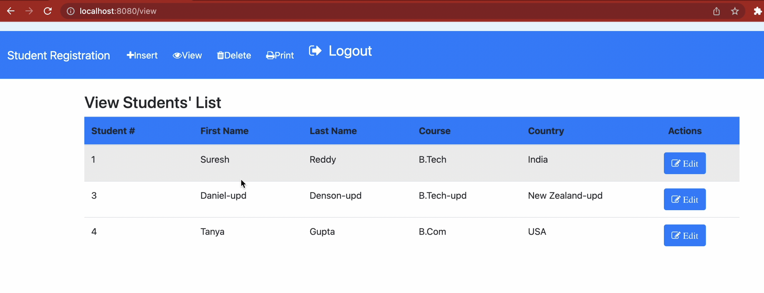

**Result:successful**

**TestNo#9:**Check the logout functionality

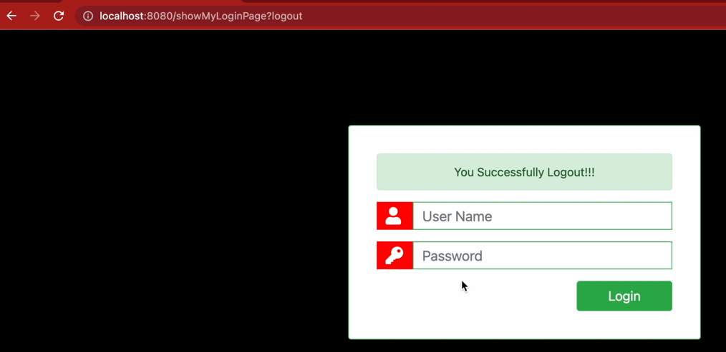

**Result:successful**

**TestNo#10**: Try to check the session by giving different link.

Enter any view,delete,print url directly into the address bar to check the successful logout.

It did not allow to go into any link

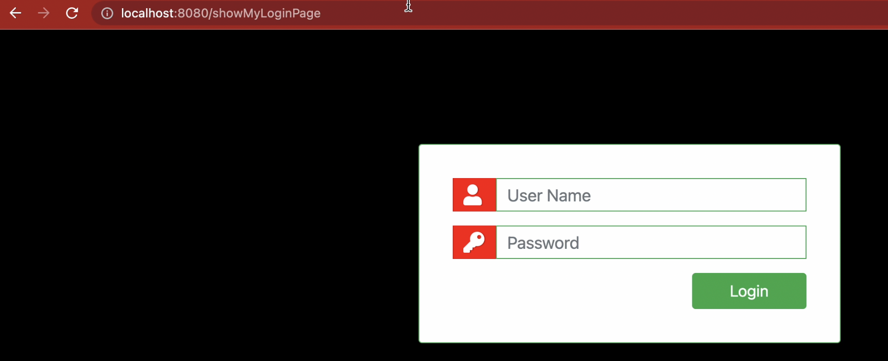

**Result:successful**